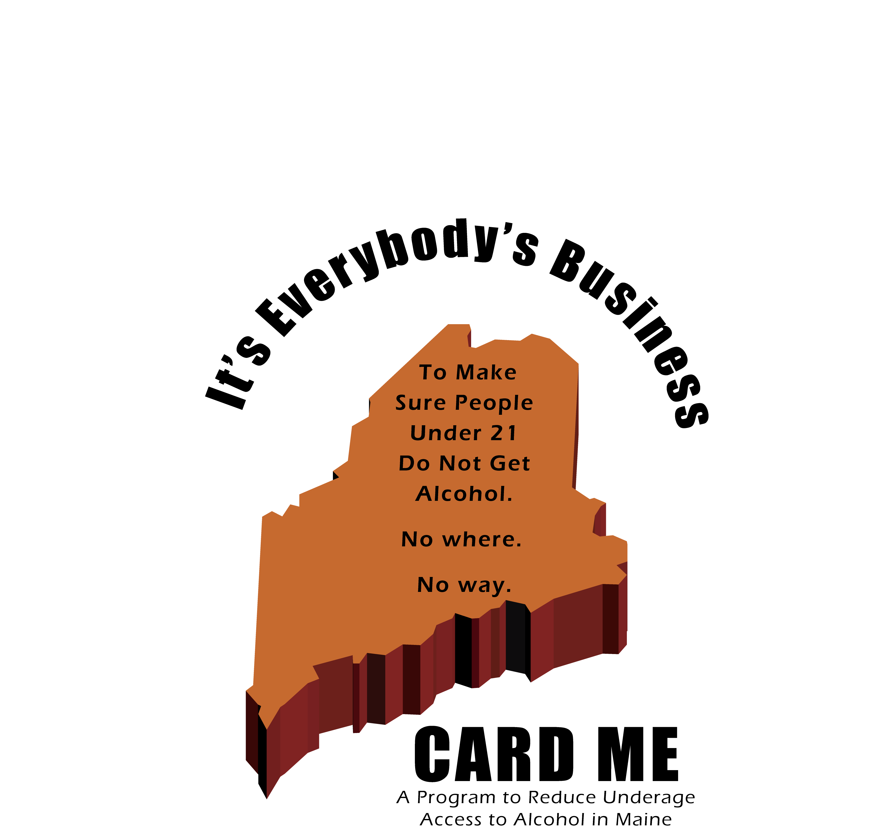

Program Implementation Guide
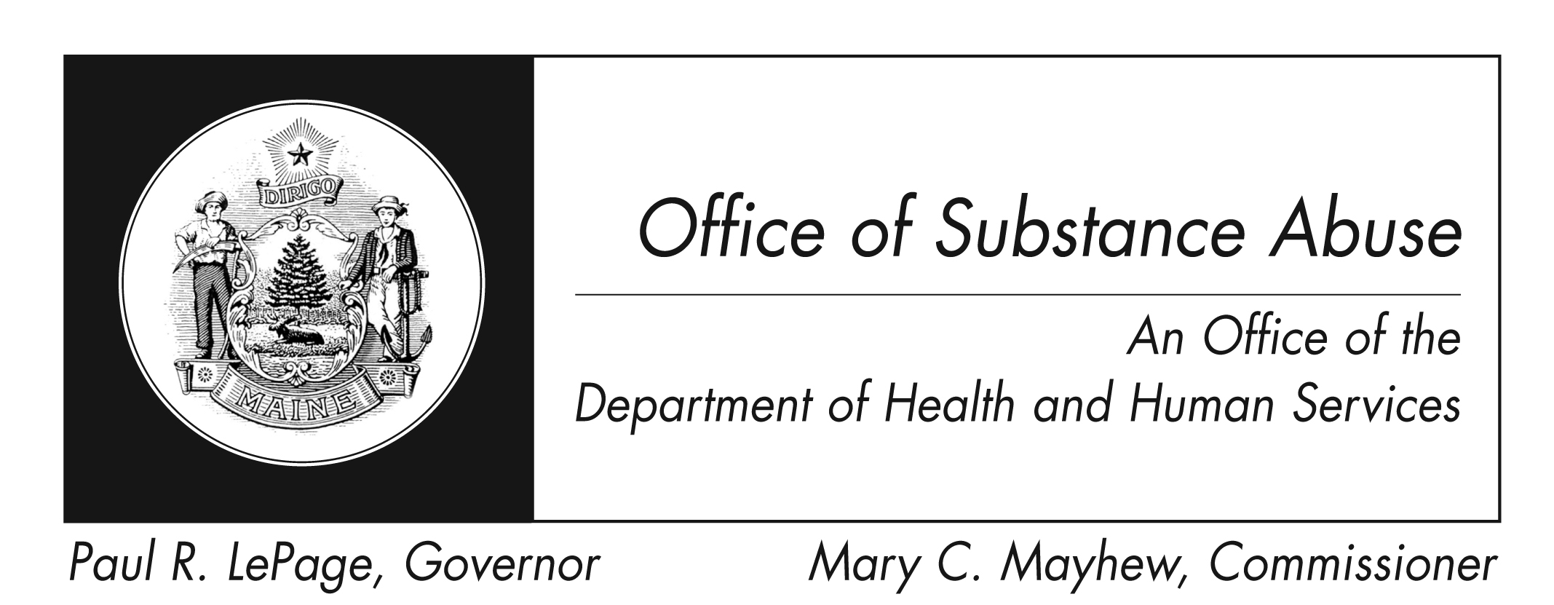

i

Produced By:

We would like to recognize the Responsible Retailing Forum for training, information and models, which supported the creation of the Card ME Program. The Responsible Retailing Forum is a joint project of Brandeis University and Florida State University that brings together diverse stakeholders—licensees, retail associations, wholesalers / distributors and producers; government and non-profit public health organizations; public safety and state attorneys general; and researchers—to explore common concerns of policy and implementation and to advance the science, and art, of responsible retailing. We would also like to thank Francis Lyons of BC Consultants for his input and knowledge, which was very helpful in creating this document.

The recommended best practices described have been drawn from the Report on Best Practices for Responsible Retailing, prepared for the Center for Substance Abuse Prevention (CSAP), and Assurances of Voluntary Compliance executed by state Attorneys General and national retail chains that establish standards and procedures for responsible retailing.

Presented Locally By:

Attorney General Steven Row

Contents
Program Rationale & Overview …………………………………………………….. 4
Recommended Steps for Working with Licensees ……………………………….. 6
- Preparing to Implement Card ME …………………………………..……….. 6
- Making Contact with Liquor Licensees …………………………………….… 7
- Explaining the Card ME Program Tools to Licensees: Key talking points …... 8
- Steps of Responsible Licensee Improvement Process…………..……………. 12
- Supporting Licensees with The Checklist Tool …………….………..…….. 13
- Supporting Licensees in Implementing Their Improvement Plan …………… 14
- Implementing the Mystery Shopper Component ………….………………….. 15
- Tracking and Assessing Efforts and Impacts ………………………………... 17
Useful Contacts ………………………………………………………………………… 18
Appendices ……………………………………………………………………………… 19
- Appendix 1: Card ME Capacity Assessment Tool ……….……….………….. 20
- Appendix 2: Card ME Implementation Planning Tool ………..……………… 22
- Appendix 3: Licensee Checklist Tool ………………….…….……..……. 24
- Appendix 4: Responsible Retail Forum’s “New Model of
Responsible Retailing” Document …………………………………………….. 28
- Appendix 5: Alcohol Retailer’s Local Marketing Code of Conduct …….…….. 30
These symbols are used throughout the guide

Key Discussion Point

2
Area for implementers to consider

Program Rationale & Overview

Reducing illegal access to alcohol by underage or visibly intoxicated persons takes commitment and collaboration from not only liquor licensees, but also the community as a whole.
Based on the Responsible Retail Forum’s “New Model of Responsible Retailing” Document (see page 28), the Card ME Program is designed to not only create awareness and behavior change among licensee’s employees, but also to support management in implementing sustainable improvements within their establishments. Additionally, the program provides community coalitions with tools and processes to work with the licensees in their community in healthy and proactive manners. The Card ME Program provides communities with a model to:
- Make it more difficult for underage and visibly intoxicated persons to obtain alcohol from liquor licensees
- Provide licensees with encouragement and positive reinforcement for their responsible alcohol sales/service efforts
- Build stronger community norms around limiting alcohol availability to underage and visibly intoxicated persons

Traditionally, most responsible alcohol sales/service programs offered to businesses selling alcohol have focused on infrequent training for seller/servers or servers. Having employees participate in state-certified seller-server training is an important strategy, and should not be replaced by this program, but infrequent seller-server training alone will not likely create long-term change. On-going education and reminders for all employees, as well as the licensee’s management having and utilizing strong policies and practices, are key components improving responsible alcohol sales.

The Card ME Program and materials aim to support licensees with a structured process to:
- Assess employees’ alcohol sales practices (carding of patrons under 27 years of age and refusal of sale to visibly intoxicated patrons)
- Review their establishment’s policies and practices relating to sales of age-restricted products
- Identify responsible alcohol sales/service "Best Practices" that may be absent
- Assist in the adoption of effective responsible alcohol sales/service practices that are not yet in use
- Assess if employees are following the responsible alcohol sales/service practices, policies, and state laws

In addition to this guide, the Card ME Program also offers materials to assist licensees in implementing best practices.
These resources include:
- Posters and signage for the public and employee areas which communicate state laws and establishment policies
- Materials to inform customers of the business’ commitment to responsible alcohol sales/service of age-restricted products
- Pay stub labels for employees to act as on-going reminders of laws and policies around selling age-restricted products
- Occurrence log for employees and management to communicate with each other about illegal or questionable attempts to purchase age-restricted products.

The Card ME Program can also provide a model, training, and tools for prevention coalitions to work with the liquor licensees in their communities to implement a “Mystery Shopper” component. The goal of the “Mystery Shopper” component is to provide licensees with a non-punitive opportunity to learn if employees are adhering to responsible alcohol sales/service best-practices and establishment policies and procedures. These check-ups provide licensees and employees with a chance to identify a potential responsible alcohol sales/service weakness before law enforcement conducts official compliance checks. Additionally, these check-ups provide an opportunity “catch” employees doing the right thing. Communities who choose to implement this component will have young-adult volunteers receive thorough training on implementing a protocol to visit licensees (as a customer) to assess if employees are following the best practices to prevent illegal alcohol sales. The results of these mystery shopper visits are reported back to the licensees’ managers via a letter (either mailed or hand-delivered by a non-youth). This model has been carefully developed with technical assistance from the RR Forum, which created the original concept and has implemented trials nationwide. Coalitions and their partner licensees will work with Card ME coordinators to ensure they are implementing this component with fidelity to the model and gather information to assess the impact.
!
Card ME Highlights:

- Card ME is not designed to be a one-shot training for employees; instead it aims to provide their managers with tools and support to address responsible alcohol sales/service with their staff on an on-going basis.

- Unlike many responsible alcohol sales/service trainings offered, Card ME aims to provide managers with practical steps, tools, and materials to use on an on-going basis in their establishments. The tools and materials are offered to communities and licensees free of charge.

- Card ME provides coalitions and licensees with a process to work together reduce the occurrence of illegal alcohol sales. It recognizes that responsible alcohol sales/service can be difficult given the time, staffing, and demand challenges they face.

- The Card ME Program stresses the importance of on-going responsible alcohol sales/service “check-ups” via the licensee checklist tool and the optional mystery-shopper component.

- The Card ME Program aims to build collaboration between licensees and communities given that reducing illegal alcohol sales is “Everybody’s Business”.

Recommended Steps for Working with Licensees

Preparing to Implement the Card ME Program

Step 1: Gain a thorough understanding of the Card ME Program

- Have the individuals who would likely coordinate the implementation of Card ME in your community participate in trainings offered by the Office of Substance Abuse

- Dedicate time to studying the Card ME process and materials

- Utilize Card ME technical assistance as needed

Step 2: Assess your coalition’s capacity to implement Card ME

- Complete the Card ME Capacity Assessment Tool

Step 3: Determine the scope of your coalition’s efforts

- Involve coalition and community stakeholders in conversations and planning

- Complete the Card ME Implementation Planning Tool to determine program plans

- Assess your coalition’s capacity to implement the mystery shopping component and determine how it would be implemented (Who? What? When? etc)

- Prepare coalition representatives to be able to knowledgeably speak with licensees about the program and the recommended best practices
?
Things to think about as you assess if your coalition plans to implement Card ME:
- Do we have members who are willing and able to commit to building relationships with and working collaboratively with liquor licensees in our community? Can they dedicate the time to becoming skilled in implementing the Card ME Program?
- How many liquor licensees are in your coalition’s area? How many licensees would your coalition aim to engage in the Card ME Program?
- How would your coalition determine which licensees would be approached about participating in the Card ME Program? How would you ensure that your Card ME Program implementation does not only focus on the licensees who are already allies?
- Does your coalition intend to support the educational and improvement planning portions of Card ME by implementing the “Mystery Shopper” component? Who would be the mystery shoppers? Who would coordinate them? Would they be paid and if so, how much? Who would oversee the process of giving licensee management the results of the mystery shopper visits?
- What resources exist to support your coalition in implementing Card ME? What additional resources would need to be secured in order to implement it well?

Making Contact with Liquor Licensees

Step 1: Make initial contact

- You will only likely be able to get a manager’s attention for 10-20 minutes due to the many demands for their time. Do not make contact until you are confident with your understanding of the Card ME Program and your ability to explain it to managers. Be prepared to highlight the key information and steps of the Program in a clear and concise manner.

- Contact the liquor licensee’s head manager during off peak times to increase the likelihood of getting them to engage in a quality conversation with you.
  - Off-premise: best times are likely from 9:30-10:30 AM or 1:30-3:30 PM
  - On-premise: best times likely to be 1:30-3:30

- Briefly introduce yourself and state the coalition you are representing. Ask them their name if you do not know already.

- If possible, give them a genuine compliment about their establishment.

- Ask if you could get a few minutes of their time to explain the free program, which may help them to protect their liquor license and the reputation of their business.
  - Ask if now is a good time for you to meet or if they wish to schedule a different time. If they say that it is not a good time for them, ask about their availability within the next week or so.
  - If they say they are not interested, leave the Card ME Guide and information about the coalition (including contact info) so that they may contact you if they decide they want to learn more about the program. Let them know they can access the program online as well, leave them the website address. (www.maineosa.org/prevention/community/licensee/cardme)

Step 2: Provide them with an overview of Card ME

- Using the information in this guide, the Guide for Establishments Selling Alcohol, and the Card ME training(s), briefly highlight the following information:
  - What is Card ME?
  - How is Card ME different from other responsible alcohol sales/service programs?
  - How is your coalition able to support them in their responsible alcohol sales/service efforts?
  - Stress that the implementation of Card ME is just one of the many strategies your coalition is implementing as part of a comprehensive approach; this is important so that they know you are not saying they are “THE” problem. Recognize that being a liquor licensee comes with many challenges and that your coalition wants to support them in their responsible alcohol sales/service.
What are the recommended steps of the Card ME responsible alcohol sales/service improvement program?
Remember: A-L-D-I-R

- Step 1: Assess Store’s Responsible Alcohol sales/service Practices
- Step 2: Learn About Best Practices for Responsible Alcohol sales/service
- Step 3: Develop a system for the store which uses “Best Practices”
- Step 4: Implement System
- Step 5: Re-assess

!
Explaining the Card ME Program Tools to Licensees:
Key Talking Points
The Card ME Program provides many useful tools to licensees. You can use the Card ME Materials Catalog to orient the licensees to the available components. To assist you in doing this, we have highlighted the aspects of each available item which you should explain to the managers you meet with.

- Guide for Establishments Selling Alcohol (bound booklet)
Aim | To support the licensee in assessing and improving their establishment’s responsible alcohol sales/service system
Target Audience | Establishment management
Contains | Information, tips, best practices, and laws related to:  - Hiring and Training Staff  - Preventing Underage Purchases  - Identifying Minors  - Identifying Fake Identifications  - Preventing Purchases by Visibly Intoxicated Individuals  - Protecting Your Business: Establishment Set-up, Promotions & Advertising  - Establishment set-up to deter theft and loitering  - Promotions & Signage
Contains | Copy of a checklist for the licensee to complete in order to:  - Identify strengths of the current responsible alcohol sales/service system or practices  - Identify areas for improving responsible alcohol sales/service at the establishment  - Identify managing, hiring, and training practices which the establishment’s management intends to improve.

  - Establishment Checklist (stapled document)
Aim | To offer a concrete way to honestly assess the licensee’s current practices; it is not meant to judge or shame
Target Audience | Establishment management
Contains | A section for them to identify some best practices which they plan to put in place to meet current gaps
Steps for use | - Determine if the manager would be willing to partner with you to complete the self assessment (recommended) so that you may help them identify which of the many Card ME tools best meet their needs  - Encourage them to use the assessment tool to routinely (at least once every six months) conduct a “check-up” on their establishment’s responsible alcohol sales/service system  - If your community is implementing the mystery shopper component, explain it to them (see page 15 of this guide FMI) and stress that these non-punitive check-ups can be very useful to them.

- Posters- several different sizes and versions
Aim | Public area signs: These signs aim to provide customers with important information about state laws and establishment policies around alcohol sales  Employee area posters: These posters display some of the key information from the Card ME Guide for Establishments Selling Alcohol.
Target Audience | Public area signs: customers  Employee area posters: employees
Contains | Public area signs: information on states laws and responsible alcohol sales/service best practices which the establishment is implementing  Employee area posters: notices about state laws and establishment policies regarding alcohol sales
Steps for use | Public area signs: They should be displayed in areas where customers can easily view them, i.e. coolers, by the registers.  Employee area posters: They should be displayed in areas where employees will have time to read them thoroughly.

- 3 Questions to Ask Before Selling Alcohol
Aim | Designed to remind and/or prompt employees to assess the customer’s age and level of intoxication before proceeding with a sale
Target Audience | Seller/servers
Contains | Questions seller/servers should ask themselves every time someone attempts to purchase alcohol
Steps for use | Encourage the manager to display the sheet next to the register and in any other locations they feel is appropriate for their establishment

- “Dear Customer” materials
Aim | To explain why the establishment is carding customers for alcohol sales
Target Audience | Customers
Contains | They are signed “The Management” so that the employees may explain that they are just doing what their employer and state law requires of them  The message may be ordered as a sign and/or as ¼ page handouts
Steps for use | Seller/servers may show to customers who question why they were carded

- Employee Reminder Labels
Aim | To provide employees with responsible alcohol sales/service information and tips on an on-going basis
Target Audience | Employees
Contains | 1 sheet of 10 different labels per employee
Steps for use | The labels are designed to adhere to paychecks or other correspondences routinely given to employees

- Incident Log
Aim | To collect information from seller/servers about alcohol-related incidents or purchase attempts which were refused
Target Audience | Seller/servers and management
Contains | A tool to collect information to allow management and other employees to identify recurrent issues or troublesome customers. By tracking situations when alcohol sales were refused, the log may be able to show that the licensee takes reasonable effort to follow the liquor laws.
Steps for use | Employees log incidents of refusal or confiscated ID

- Thank You for Carding Cards
Aim | To provide an opportunity to provide positive reinforcement for employee’s carding behaviors. (Something they do not often receive)
Target Audience | Coalitions and licensee management
Contains | A message thanking the employee for doing the right thing
Steps for use | Some communities and/or establishments choose to offer additional rewards or recognition for employees who receive these cards (i.e., a recognition ceremony, a free non-alcoholic beverage for their break, a BOGO certificate to a local movie theater, etc.)

?
Things to think about as you assess if your coalition plans to implement CARD ME:
- Would our coalition like to have our name/logo on the posters? If so, you could put a label on the pre-printed posters or you could get an electronic version and pay for the printing yourself.

- Is your coalition going to plan to complete the checklist with the store manager? How will your respond if they do not want to complete it with you? How will you diffuse a manager’s desire to “put on a front”? While these are individual choices, the CARD ME training and technical assistance can support you in this area.

- Will your coalition/community plan to engage in the “Thank You for Carding” recognition program? How will you increase awareness of the program to the community and licensees so that they know what the orange cards represent?

- What resources exist to support your coalition in implementing CARD ME? What additional resources would need to be secured in order to implement your plans?

Steps of Responsible Alcohol Sales/Service Improvement Process
Below are the steps you should encourage licensees to undertake via the Card ME Program. Pay careful attention to your tone and stress that the Card ME Program is designed to provide them with practical information and tools to implement best practices. Card ME is a voluntary program designed to aid a licensee in lowering their overall risk of illegal alcohol sales; illegal alcohol sales may result in costly fines, higher insurance rates, and/or liability issues.

Step 1: Assess existing responsible alcohol sales/service practices

- Complete the Card ME “Checklist” (see pages 17-20 of the Card ME Guide for Establishments Selling Alcohol) to gauge current responsible alcohol sales/service practices. The goal of this is to identify areas for improvement, so being honest and objective will support the effectiveness.

Step 2: Learn about best practices for responsible alcohol sales/service which could be added

- Read the guide. It highlights pertinent state laws and highlights best practices and policies for alcohol sales.

- Read “New Model for Responsible Retailing” (see Appendix 2 on page 21 of the Guide for Establishments Selling Alcohol), which highlights why collaborative efforts by management, employees, and the community are important.

Step 3: Develop an improvement plan which utilizes “Best Practices”

- Based on the results of the checklist, determine which areas need improvement

- Identify the best practices which will help meet these needs/weak areas and figure out the best ways to implement them.
  - Write out a detailed plan of action and seek feedback from others, including employees.

Step 4: Implement the improved responsible alcohol sales/service system

- Build “buy in” from all employees and make sure they understand why having the system protects them, the establishment, and the community.

- Utilize the materials and support available through the Card ME Program and the local coalition

Step 5: Re-assess how the system is working

- Continuously monitor and assess how the system is working and make modifications as necessary.
  - Re-administer checklists at least every 6 months (or more often- especially if there has been significant employee turnover or responsible alcohol sales/service changes.)
  - Conduct quarterly mystery shopper assessments to see if employees are following policies and best-practices. (Optional)
  - “Catch” employees doing the right thing and give them positive reinforcement.
Supporting Licensees with The Checklist Tool
Step 1: Orientate the licensee to the tool and its purpose
- Stress that you want them to feel comfortable enough to be open and honest because the process will be much more meaningful for them. Let them know that you will not be judging or “grading” them on their responses; rather your goal is to use the assessment results to help identify which best practices and Card ME Program tools may best meet their needs.
- Determine if they are willing to complete the assessment with you. Stress that because you are familiar with the Card ME Program information and materials you may be able to efficiently highlight the parts that may be most beneficial to them.

Step 2: Complete the current practices portion of the assessment
- For each section of practices (Management, Hiring, and Training) check off the “Y” box for practices which are consistently being implemented currently and “N” for practices not currently being consistently implemented.
- For each section count up the total number of “Y’s” and “N’s” and record that number in the totals box. This will allow the licensee to measure an overall starting point.
- Stress that you want them to feel comfortable enough to be open and honest because the process will be much more meaningful for them. Let them know that you will not be judging or “grading” them on their responses, rather your goal is to use the assessment results to help identify which best practices and tools may best meet their needs.

Step 3: Complete the overall risk portion of the assessment
- Based on the current practices, have the licensee determine what they feel their overall level of risk is. This will help them, and you, gauge their motivation to under-take an improvement process.
- As appropriate, recognize the areas they are currently strong in. Engage them in dialogue about which areas they are most concerned about and/or motivated to improve.
- Point out Card ME information and materials which they may find will support them in enhancing their responsible alcohol sales/service efforts.

Step 4: Create an improvement plan that increases the consistent utilization of best practices
- As necessary, refer to the Card ME Guide for Establishments Selling Alcohol to learn about best practices for selling alcohol
- Encourage the licensee to be very detailed in their plans to implement a best practice by answering: Who? What? When? Where? Why? and How?
- Encourage them to get feedback on their plan from others at their establishment and/or to engage other employees in the plan’s development
- Educate them about how the Card ME Program and your coalition may support their responsible alcohol sales/service efforts.

Step 5: Revisit the assessment within 6 months of implementing the improvement plan to measure change and adjust plan as necessary
- Check in with the licensee to see which aspects of the improvement plan, if any, were implemented
- Encourage them to re-complete the assessment to see what improvement has occurred and what future effort may be warranted
- Get their feedback about how the Card ME Program may or may not have proved valuable to their efforts; solicit their comments about ideas for improving the program.

Supporting Licensees in Implementing Improvement Plans
Step 1: Ensure that they are familiar with the Card ME Program materials and how to utilize and access them

- If necessary re-orientate them to the available materials.
- Communicate that they may order materials by contacting you. Having the material orders and shipment go through your coalition aims to increase the amount of contact you have with licensees in your community- a key component to establishing stronger relationships.
- Get their feedback about how the Card ME materials may or may not have been valuable to their efforts; solicit their comments about ideas for improving the program.
- Make sure that both you and the licensee take advantage of training and technical assistance made available through the Card ME Program.

Step 2: Work with the Card ME Program and licensees to collect information and data which may evaluate the impact of efforts

- Licensees involved in Card ME will be more likely to continue participation, and may even encourage other licensees to participate, if they know it is making a difference.
- Seeking feedback and genuinely being interested in their ideas and experiences will not only strengthen the Card ME Program and its potential for your community, but it may also help build rapport between you and the licensee.
- Consider implementing the Mystery Shopper component (see page 15) of this guide.
- Collect non-licensee data such as compliance check results from local law enforcement agencies to triangulate results.

Step 3: Educate them about your community coalition, its efforts, and upcoming events

- Ask if they wish to be on a mailing list for newsletters or electronic updates.
- Highlight how coalition involvement may strengthen their relationships with community stakeholders allow them to because recognized in the community as a responsible licensee.
- While licensees may not be able or willing to attend coalition meetings consistently, provide sufficient notice and encouragement to attend any meetings which may be particularly relevant to them. Like all coalition members, they will be more likely to participate when they can answer “Why am I here?”, “What is my role?”, and “What’s in it for me?”

Step 4: Work with community and state stakeholders to develop more ways to support licensees in their responsible alcohol sales/service efforts

- Assess if there are local and/or state policies or systems changes which would support responsible alcohol sales/service efforts.
- Consider community education and norms campaigns to improve public support of licensees’ efforts.
- Look for opportunities to provide positive recognition for licensees’ efforts.

Implementing the Mystery Shopper Component

Card ME’s Mystery Shopper Component
Phases of Community Coalition Implementation

Preparation Phase: Capacity Assessment & Program Awareness
Each community who wants to implement the mystery shopper component should work with the Maine Office of Substance Abuse to assess their capacity and to receive training and technical assistance which will better prepare them to undertake this component. One key capacity/readiness is the identification of an individual who will coordinate the mystery shopper component locally to make sure it is running appropriately and effectively. Part of this assessment phase is to identify potential mystery shoppers and funding to pay them with. It is recommended that mystery shoppers be college students from appropriate majors (i.e. nursing, law enforcement, social services). Mystery shoppers for the underage sales assessment must be 21 years of age (or older,) but should not look over the age of 25.

OSA is able to provide local coordinators with training and tools related to utilizing the mystery shopper protocols, tracking and reporting process, and technologies. Communities will be responsible for the local coordinator’s time and access to necessary computer equipment. Mystery shoppers will be trained by trainers who have been adequately prepared for this role and who have worked with OSA to prepare.

Phase I: Shopper Establishment Visits/Assessments & Feedback
Community coalitions which have completed the preparation phase are then ready to identify and train college students from appropriate majors (i.e. nursing, law enforcement, social services) to be mystery shoppers and provide establishments’ management with the results. Mystery shoppers for the underage sales assessment must be 21 years of age (or older), but should not look over the age of 25. The visits would be unannounced and occur regularly (quarterly for underage sales visits). Mystery shoppers will do the following:

Step 1: Underage Sales Mystery Shopper Establishment Assessment

A) While at the licensed establishment, the mystery shopper will assess the following establishment factors:
- Alcohol placement in relationship to exit areas and staff members (i.e. could a person easily take/steal alcohol without being detected?)
-Are there signs posted regarding not selling alcohol to anyone under 21? (a state law)
-Are there alcohol promotions aimed at youth or college students (since most are under the age of 21)?
-Are parking lots adequately lit and/or are there parts, which might make it easy for transfers to take place?

B) While at the establishment, the student attempts to purchase alcohol without showing an ID. If the employee(s) request an ID, the shopper will present them with a green card to signify that the seller/server followed the carding law. If not asked for an ID, the shopper will present a yellow card instead of payment to provide the seller/server with the feedback that they failed to properly ID the patron. The cards will have text printed on them to explain to the seller/server why they have received the card.

Step 2: Mystery Shopping Results Communicated to Management

A written feedback report should be given to each liquor licensee’s manager regarding the findings from the mystery shopping:
- If employees did check for an ID and refused the sale, the establishment’s management will receive a positive feedback letter. These establishments will be encouraged to engage in responsible alcohol sales/service training opportunities to assist in enhancing their good practices.
- If the seller/servers did not refuse the sale, the feedback letter to the establishment’s management would point out the error(s) and offer training and support opportunities to assist them in improving their alcohol sales policies and practices.

Phase II: Training and Resource Dissemination
Community prevention coalitions can work with willing licensees to implement the educational component of the Card ME Program:
- Completing the checklist process
- Studying the Card ME Guide to learn about best practices
- Creating an improvement plan for liquor-related practices and policies
- Implementing the improvement plan using Card ME resources as support
- Continuing communication and collaboration with community coalition

Phase III: Follow up checks
Mystery shopper checks and feedback letters will be repeated as follows:
- Quarterly for underage sales visits

Tracking and Assessing Efforts and Impacts
Tracking the efforts and impacts of the Card ME Program is essential.

Much of the data collection for Card ME will be done through KIT Solutions.

The mystery shopper component also needs to be evaluated. Participants in the mystery shopper component are expected to report the results into the reporting system specified by the Office of Substance Abuse.

Not only should you be tracking Card ME by the number of establishments participating, but you should be evaluating the compliance rate in your area. In order to evaluate your compliance rate, you will need to, first, develop a good working relationship with your local police department or sheriff’s office. Determine whether or not your police department conducts compliance checks. If they do, ask them to share their results with you after each detail. If they do not, find out if this is something the department is interested in doing. It is recommended that any department wishing to do compliance checks contact Liquor Licensing (207) 624-7220. There is a compliance check tracking tool on the Underage Drinking Education Technical Center (UDETC) website: www.udetc.org.

After collecting the data, there are four main ways to tell if your program is having a positive effect on the community.

First, should be an increase in the number of licensees participating in the program. This should cause an increase in the number of community members who are exposed to the program materials (cooler posters, register cards etc).

Second, if you’re using the mystery shopper component, there should be an increase in the number of seller/servers who receive positive feedback about their selling practices. The ultimate goal is for all licensees in your area to regularly pass inspections.

The third way to know if your program is effective is by assessing the data received from the local law enforcement on their compliance checks. In the beginning you may see an increase in violations, but as the program goes on, the number of violations should decrease.

Fourth, if your high school participates in the MYDAUS or Integrated Survey, there are certain questions you can use to track change across years. One question is around the perception of how easy it is to get alcohol. Although this question cannot concretely determine whether the program is effective, it can help a community gauge where it’s at as far as availability. Please remember that availability also includes other methods of getting alcohol than just purchasing it directly from the licensee.

Tracking and assessing your efforts on the Card ME Program are just as important as implementing the program. Please be sure to develop a plan on how you will do this before you begin implementation.

Useful Contacts

Maine Department of Public Safety’s Liquor Licensing Division
164 State House Station
Augusta, Maine 04333-0164
Offices Located at 45 Commerce Drive
Augusta, Maine
Phone: (207) 624-7220
Fax: (207) 287-3424
http://www.maine.gov/dps/liqr/index.html

Maine Office of Substance Abuse
41 Anthony Ave
#11 State House Station
Augusta, ME 04333-0011
207-287-2595
TTY: 1-800-606-0215
Fax: 207-287-4334
www.maineosa.org

APPENDICES

1. Card ME Capacity Assessment Tool
The capacity assessment tool is designed to help a coalition assess their ability to implement the program with fidelity. There are questions which are meant to get a coalition to think about their capacity and the community’s readiness to implement the program.

2. Card ME Implementation Planning Tool
The implementation planning tool designed to get coalitions thinking about how they will actually carryout the program in their service area. The questions help figure out how many licensees they will try to work with, what kind of licensee (small establishment, chain, pharmacy etc) will be approached, who the lead person on the project is, how many hours they will commit to the program, etc.

3. Licensee Checklist Tool
The checklist tool is a modification of an assessment tool developed by the Responsible Retailing Forum. The Responsible Retailing Forum is a joint project of Brandeis University and Florida State University that brings together diverse stakeholders—licensees, retail associations, wholesalers / distributors and producers; government and non-profit public health organizations; public safety and state attorneys general; and researchers—to explore common concerns of policy and implementation and to advance the science, and art, of Responsible Retailing.

4. Responsible Retail Forum’s “New Model of Responsible Retailing” Document
The Responsible Retailing Forum, a joint project of Brandeis University and Florida State University, has developed a model for how different stakeholders (establishments, community members, and policy makers) can work together to improve the responsible retailing of age-restricted products.

5. Alcohol Retailer’s Local Marketing Code of Conduct
This Code of Conduct is a voluntary code created by the Maine Youth Empowerment and Policy (YEP) group in partnership with a number of Maine alcohol retailers to reduce youth exposure to alcohol marketing.

CARD ME PROGRAM CAPACITY ASSESSMENT TOOL

- Has the coalition been educated about the Card ME Program, its basis, goals, and components? Is the coalition supportive of the idea of potentially implementing Card ME? It’s Mystery Shopper component?

- Which coalition members or staff members are willing and able to commit to building relationships with and working collaboratively with liquor licensees in our community?

- Can they dedicate the time to becoming skilled in implementing the Card ME Program?

- How much time are they able to dedicate to implementing Card ME? Does their time availability differ during different times of years or months?

- How many liquor licensees are in your coalition’s area?
On-premise?

Off-premise?

Continues on next page ➔

- How many of these licensees does your coalition already have a strong relationship with? How are you currently involving licensees in your coalition or its efforts?

- Which prevention efforts in your community would Card ME support or complement?

- Which prevention efforts in your community would Card ME potentially compete with or conflict?

- What resources exist to support your coalition in implementing Card ME? What additional resources would need to be secured in order to implement Card ME?

Other Capacity Assessment Notes:

CARD ME IMPLEMENTATION PLANNING TOOL

- Who will be coordinating the implementation of Card ME in your community? This is the person who will be the lead contact and who will carryout tracking and evaluation functions.

- Who will be implementing Card ME in your community (please include names, positions/roles, and number of hours a month they are willing to dedicate to the program).

- When will your coalition begin implementing Card ME? End (If known)?

- Is your coalition implementing the No Buts Program? If yes, how do you plan to coordinate the implementation of both No Buts and Card ME?

- How many licensees does your coalition aim to engage in the Card ME Program?
On-premise?

Off-premise?

- How will your coalition determine which licensees would be approached about participating in the Card ME program? How will you ensure that your Card ME Program implementation does not only focus on the licensees who are already allies?

- Is your coalition going to plan to complete the checklist with the establishment manager? How will your respond if they do not want to complete it with you? How will you diffuse a manager’s desire to “put on a front”? While these are individual choices, the Card ME training and technical assistance can support you in this area.

Continues on next page ➔

- Would our coalition like to have our name/logo on the posters? If so, you could put a label on the pre-printed posters or you could get an electronic version and pay for the printing yourself.

- Will you coalition/community plan to engage in the “Thank You for Carding” recognition program? How will you increase awareness of the program to the community and licensees so that they know what the orange cards represent?

- Does your coalition intend to enhance the educational and improvement planning portions of Card ME by implementing the “Mystery Shopper” component?
Who will be the mystery shoppers?

How will they be recruited?

Who will coordinate them?

Will they be paid and if so, how much?

Who will oversee the process of giving licensee management the results of the mystery shopper visits?

- What resources exist to support your coalition in implementing Card ME? What additional resources need to be secured in order to implement your plans? How will this happen?

Other implementation planning notes
Licensee Checklist Tool

This tool was designed to provide you with a way to assess your establishment’s responsible alcohol sales/service system and to identify areas for improvement. The first two pages of the tool contain a chart where you can inventory which specific responsible alcohol sales/service best practices are already being consistently implemented and which are not. The second part of the tool provides an opportunity for you to identify some best practices you plan to adopt in order to improve your responsible alcohol sales/service system and reduce your establishment’s risk for illegal alcohol sales.

Instructions

- Complete the “Today” column of the chart (on pages 1 & 2 of the checklist) by checking the “Y” box for each line if your establishment is currently practicing that consistently. You should check the “N” if your establishment is not implementing that practice consistently or at all.

- On Page 3 of the tool, indicate what you feel your establishment’s level of risk for illegal alcohol sales is and then use the blank space to list any policies or practices you plan to integrate into your establishment’s responsible alcohol sales/service system.

- Refer to the Card ME “Guide for Establishments Selling Alcohol” to learn details about the policies and best practices which could improve your establishment’s responsible alcohol sales/service system and lower your risk. Review the items in the Card ME Licensee’s Tool Kit and identify which you plan to use. Use the order form included in the tool kit to get additional quantities.

- Over the next several months take action to improve your establishment’s responsible alcohol sales/service system.

- Six months after you completed the Card ME Checklist, complete the “In 6 Months” column of the chart on pages 1 and 2 of the tool. Assess where your establishment has made improvements and identify areas needing further improvement.

Card ME Checklist of Current Responsible Alcohol sales/service Practices

Today’s Date: _________________
Management Practices | Today  Y N |  | In 6 Months  Y N
Do you have a copy of state and local liquor laws available in your establishment?
Do you have a written establishment policy about not selling alcohol to underage customers?
Do you have signs posted in clear view that say:
your establishment will not sell or provide alcohol to people under the age of 21?
anyone who appears younger than 27 will be asked for an ID?
shoplifters will be prosecuted?
no loitering outside your establishment?
Do your seller/servers have a reasonably clear view of the outside of the establishment?
Can your alcohol placements be easily monitored by employees? *Secure approval from Liquor Licensing before changing placement
When setting up in-establishment promotions, do you consider the age of the people who might be most influenced by the displays? (E.g. do the displays use inflatable products that might be viewed as toys or does the display use things that appeal to people under the age of 21?)
Do you have a system for recording sale of alcohol refusals?
Do you consistently tell your employees that you appreciate and support their efforts to obey laws and policies?
Please tally your checks for this section and record them in the space provided at the end of the assessment

Hiring Practices | Today  Y N |  | In 6 Months  Y N
Before hiring a new employee do you :
Review state and local liquor laws and establishment policies?
Talk about the importance of following laws related to not selling alcohol to people under the age of 21?
Talk about the consequences under state/local laws for seller/servers who sell alcohol to minors, including the establishment policy about continued employment?
Ask them if they have ever been cited for selling or supplying alcohol to anyone under the age of 21?
Ask them to read and sign your establishment’s policy on alcohol sales to underage people?
Please tally your checks for this section and record them in the space provided at the end of the assessment

Continues on next page ➔
Card ME Checklist (page 2 of 3)

Training Practices | Today  Y N |  | In 6 Months  Y N
Before the new employee begins work do you ask if they understand state and local liquor laws and establishment policy regarding alcohol sales to minors and review if necessary?
Does new employee training include demonstration and practice of the following items?
How to ask for ID
How to calculate age
How to identify a false ID
When and how to ask for a second ID
Steps that must be taken when retaining an ID
Reasons to refuse a sale (including visibly intoxicated persons)
How to refuse a sale
How to resist customer pressure and handling abusive conduct
How to identify a third party sale
How to monitor the establishment’s surroundings
Please tally your checks for this section and record them in the space provided at the end of the assessment

Please record scores here. | Today  Y N |  | In 6 Months  Y N
Management Practices
Hiring Practices
Training Practices
Total

Continues on next page
Card ME Establishment Checklist (page 3 of 3)

Based on your answers to the previous items on this assessment tool, what do you feel your establishment’s risk level is for underage sales?

____ High risk of underage sales
____ Moderate risk of underage sales
____ Low risk of underage sales

For each of the sections, what are some practices your establishment will put in place to strengthen its responsible alcohol sales/service?

Before completing this section, you may find it helpful to read the Card ME “Guide for Establishments Selling Alcohol” which provides more information and best practices related to responsible alcohol sales/service.

Managing Practices

Hiring Practices

Training Practices


Schneider Institute for Health Policy,Heller Graduate School, Brandeis University
Institute of Science and Public Affairs, Florida State University
The Responsible Retailing Systems Project
Validating A New Model for Responsible Retailing

In 2001, a team of national experts composed a federal guidance document for the Center for Substance Abuse Prevention (“CSAP”)—Report on Best Practices for Responsible Retailing (“BP Report”)—reflecting the experiences and insights of retailers, alcohol control boards and other state regulatory and enforcement agencies (“R/E agencies”), state attorneys general, advocates and academic researchers concerning effective measures to prevent underage sales of alcohol and other age-restricted products. The principal innovations of the BP Report are to:
- Identify the components of a continuing system of responsible retailing (RR)
- Establish the importance of managerial supervisory practices and accountability
- Identify an integrated, 3-tier model for RR. This model replaces a deterrence only model (in which enforcement alone is meant to deter underage sales) with a collaborative model, based upon Community Policing principles, in which state R/E agencies additionally assist retailers to identify, implement and sustain effective RR systems.
Following an examination of this model at the 2003 RR Forum, the state alcohol R/E agencies in Alabama, Iowa, Missouri and New Mexico have begun a pilot demonstration of this model of an integrated RR system.

The Integrated RR System model recognizes that RR involves three distinct, interconnected levels:
1. Establishment Level. An effective RR system has, at its core, a) point-of-sales protocols for verifying age and refusing sales to customers who may be underage (and/or intoxicated), and b) establishment practices for hiring, training and supervising sales seller/servers. The model emphasizes the role of managers in reinforcing correct age verification / sales refusal conduct through explicit establishment policies, employee training and performance monitoring and their own personal conduct. In the RR Systems Project, the state R/E agency will provide participating retailers with a Planning Tool that is being developed as a quality improvement tool to assess current practices for age verification / sales declination at the point of sales as well as hiring, training and supervisory policies. The R/E agency and its industry partners will assist retailers to adopt community-appropriate best practices by providing licensees with any needed resources (e.g. training for seller/servers, point-of-sales materials, supervisory strategies for managers) and mechanisms (e.g. mystery shopper inspections) to adopt and sustain a system of responsible retailing. Through a quasi-experimental design, the project will determine the individual and synergistic effects of the Planning Tool and frequent mystery shopper reports.

2. Community Level. The 2nd tier of an integrated RR System is a community context which connects the public and private sectors in a collaborative, problem-solving approach to underage sales and use. Retailers are seen not merely as objects of enforcement who are “compliant” or “non-compliant” but rather as active partners with R/E agencies and advocates to address community-level patterns of underage acquisition and use. This model, based upon the principles of “Community Policing,” will allow stakeholders to address the actual patterns of underage access and use of alcohol within the study communities: Birmingham, AL; Des Moines, IA; Springfield, MO; Santa Fe, NM (with two more to be added), and to consider coherent strategies to reduce alcohol use and abuse by minors.

3. Policy Level. The 3rd tier of an integrated RR system consists of the public policies at the state (or local) level that encourage the adoption of effective RR practices. Some states mandate RR training for establishments and their employees. Others create positive incentives—such as reductions in liability insurance, or mitigation for violations—for establishments which engage in approved RR activities. Two important policy issues that the project will address are: a) linking non-compliance to remedial training and b) establishing a stable funding mechanism so that training, materials and mystery shopper inspections can be sustained.

Project Goals: The goals of the RR Systems Project are:
- Validate Best Practices for retailers identified in the BP Report prepared for CSAP
- Develop a model for state alcohol R/E agencies to engage retailers in RR activities
- Identify the requirements for statewide implementation of RR systems and the potential roles of public and private stakeholders in their continuing operation.

Project Partners. The lead organization for the RR Systems Project is the RR Forum, which was launched by—and receives staff support from—Brandeis University and Florida State University. The dual objectives of the RR Forum are 1) to identify and promote Best Practices to prevent underage sales of alcohol, tobacco and other age-restricted products, and 2) to engage diverse stakeholders in the examination of RR practices and policies. The work of the RR Forum was cited by the Federal Trade Commission’s September 2003 Report to Congress, Alcohol Marketing and Advertising, which notes:
During this past year, the many stakeholders in the alcohol control process, including state alcohol agencies, state law enforcement officials, representatives of major retail outlets, and alcohol producers, wholesalers, and distributors, organized under the aegis of the RR Forum to evaluate what changes are needed to reduce minors' ability to purchase alcohol in retail outlets. Support is needed for the efforts of organizations, like the RR Forum, that can conduct rigorous field studies of the efficiency of alternative approaches to improving enforcement of minimum age purchase laws.
Other project partners are the Alabama Alcohol Beverage Control Board, the Iowa Alcoholic Beverages Division, the Missouri Division of Liquor Control and the New Mexico Alcohol and Gaming Division. Additionally, a number of national organizations and corporations who participate in the RR Forum have lent their support to the RR System project and facilitated the involvement of their affiliates in the study states.
Contact: Brad Krevor, Ph.D, RR Forum Project Director Krevor@brandeis.edu , 781 736-4839.
Alcohol Retailer’s Local Marketing Code of Conduct

Youth Empowerment and Policy (YEP) group, a statewide youth advocacy group consisting of high school and college students created this first in the nation Alcohol Retailer’s Local Marketing Code of Conduct. YEP members developed the Code in partnership with local alcohol retailers. In 2005, YEP conducted a survey of 500 Maine students that demonstrated that young people are exposed to a significant amount of alcohol marketing and that young people were attracted to and influenced by this marketing. “We are concerned and upset by the negative impact underage drinking has on our friends, schools and communities,” said Vanessa Ouellette, YEP member, “and we are determined to do something about it.” YEP members determined that they wanted to reduce youth exposure to alcohol marketing and looked at local point of sale marketing as something they might be able to influence.

1. It is the responsibility of every retail manager to be aware of how alcohol marketing in their establishments may affect underage individuals and to minimize the impact of alcohol advertising on youth to the best of their ability.

2. To the greatest extent possible, given establishment size and other limitations, placement of alcohol products and displays should be in areas less frequented by children. An effort should be made to keep alcohol products and displays away from areas that display candy and toys.

3. Alcohol signage should be placed above children’s eye level and should not be located in areas frequented by children, i.e. Establishment entrances, checkout areas, candy, and toy areas.

4. Displays featuring sports figures, blow-up items, and appeals to sex symbols should be minimized. As the retailers stated “price should sell the product”.

5. Outside signage should comply with state law.

6. Local retailers need to regularly and consistently ask their distributors and vendors to comply with this code and provide materials that comply with this code.

For more information about the Youth Empowerment and Policy Project:

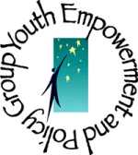

AdCare Educational Institute
75 Stone Street
Augusta, ME 04330
Telephone: 207-626-3615
TTY: 207-623-0830
Fax: 207-621-2550
On the Web: http://www.neias.org/YEP/
Maine Office of Substance Abuse
41 Anthony Avenue
#11 State House Station
Augusta, ME 04333-0011
Ph: 207-287-2595
TTY: 1-800-606-0215
Email: osa.ircosa@maine.gov
Web: www.maineosa.org

Printed April 2010

This project was supported by Grant No. 2007-AH-FX-0007 awarded by the
Office of Juvenile Justice and Delinquency Prevention, U.S. Department of Justice with support from the Fund or Healthy Maine and administered through The Maine Office of Substance Abuse.

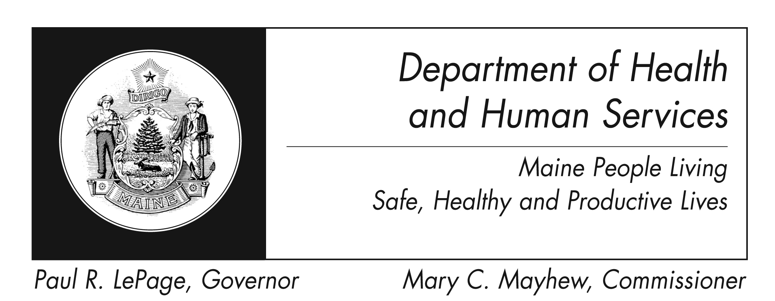

The Department of Health and Human Services does not discriminate on the basis of disability, race, color, creed, gender, sexual orientation, age or national origin in admission or access to or operations of its programs, services, or activities, or its hiring or employment practices. This notice is provided as required by Title II of the Americans with Disabilities Act of 1990 and in accordance with the Civil Rights Act of 1964 as amended, Section 504 of the Rehabilitation Act of 1973 as amended, the Age Discrimination Act of 1975, Title IX of the Education Amendments of 1972 and the Maine Human Rights Act. Questions, concerns, complaints or requests for additional information regarding the ADA may be forwarded to DHHS ADA Compliance/EEO Coordinator, SHS #11, Augusta, ME 04333; (207) 287-4289 (V) or (207) 287-3488 (V), TTY: 800-606-0215. Individuals who need auxiliary aids or services for effective communication in programs and services of DHHS are invited to make their needs and preferences known to the ADA Compliance/EEO Coordinator. This information is available in alternate formats upon request.

Caring..Responsive..Well-Managed..

We Are DHHS.

